Alright sick we’re gonna do Assembly now!

Make another sketch (constrained)

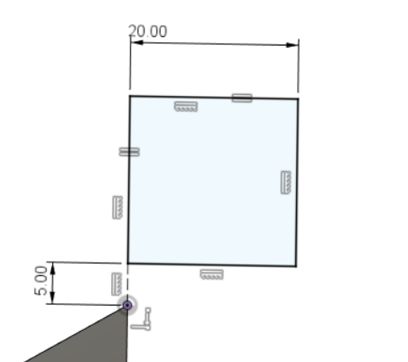

This is what mine looks like

Now extrude it

Cool; this is what my document looks like

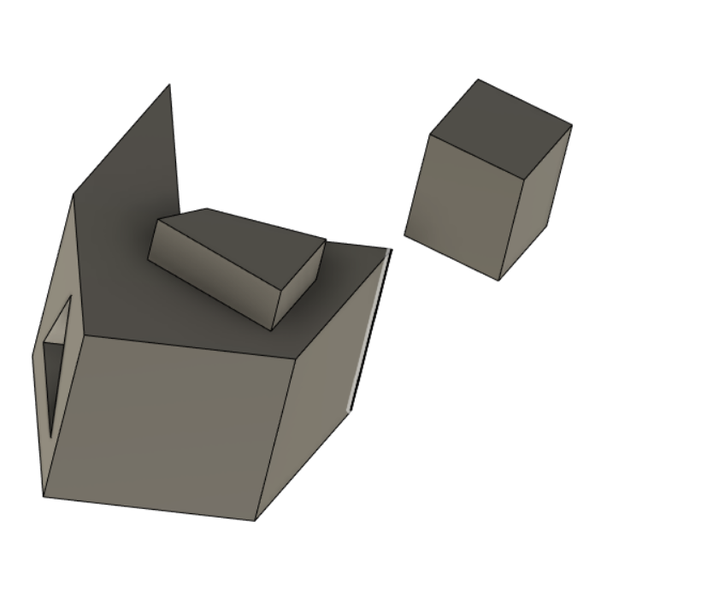

Make components!



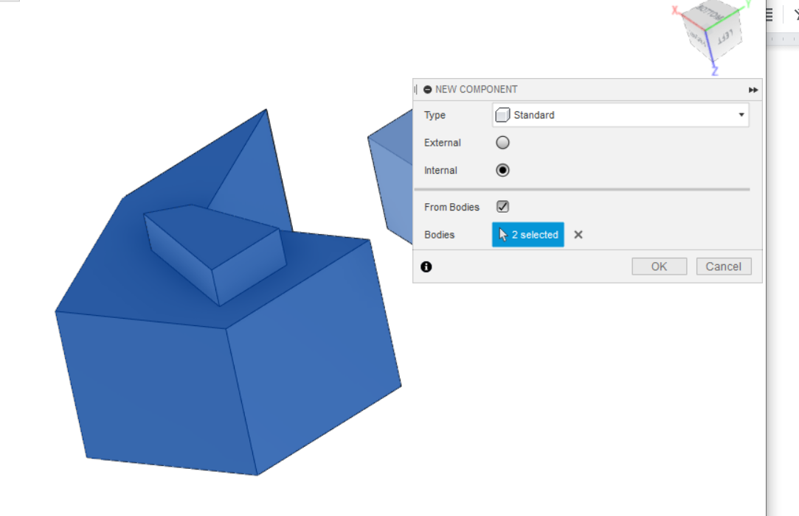

You’re going to separate the two bodies and make them seperate parts by doing this

Check “from bodies” and select both objects

After you click okay you should be able to move around the parts

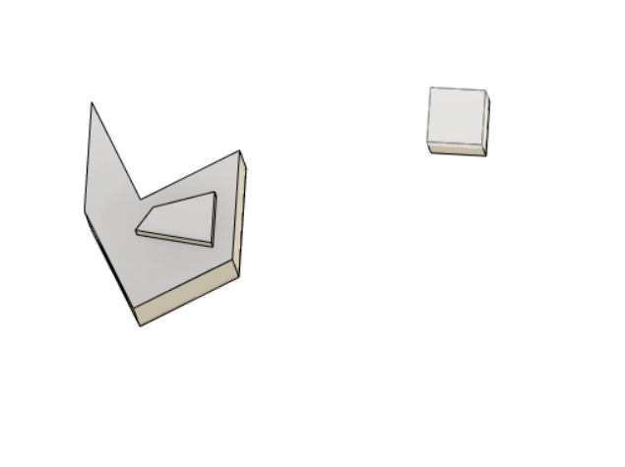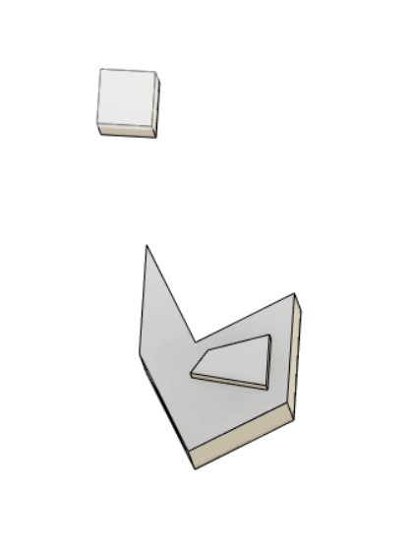

See look! Moving!

Alrighty! It is now time for assembly

Unlike onshape or solidworks: you can assembly inside of a part studio

What assembly does: it will tell you if your pieces are going to fit together as expected or not

* You can then throw it into a simulation and you’ll get some data out of it
* Usually you’re going to design pieces of an assembly inside of the same part studio since it’s more efficient
  + So assembly will let you know how it’s going to rotate/ move together if you chose that option

Alright doing time!

Go to assembly

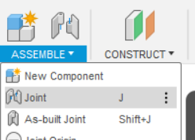

Join

You may have moved the things so you’ll get this message

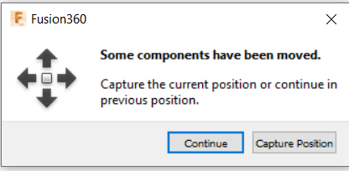

* For this tutorial it doesn’t matter just click continue

Joining:

So these act as mate connectors in onshape kinda

You’re gonna select the mates you want to connect to each other

* Going to be the faces of the things

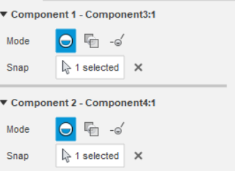

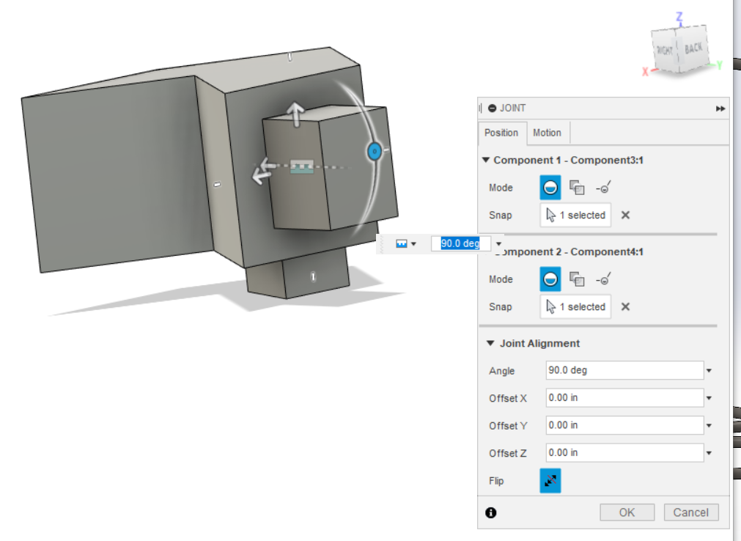

This is what I did and what I got!

The join alignment is to tweak the things if you’d like

* Alternatively you could make your own mates



Aka join origin

Alright! So for the fuselage team we’re mainly going to be using the 3D sketching so that’s next! Go there!